Developing Elephantine Island in the Nile River, south of Aswan, by re-planning the island and providing the island with all the necessary services to create a decent life for the island's residents and serve its tourism.
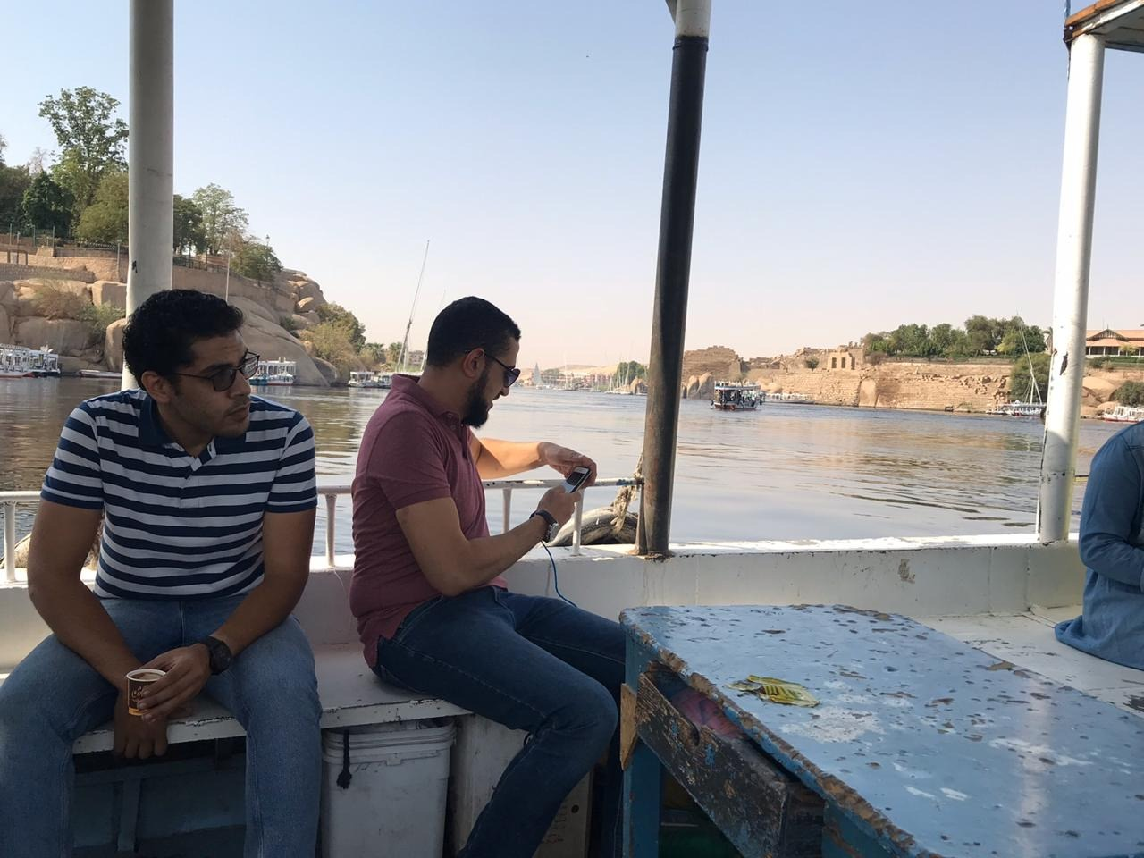
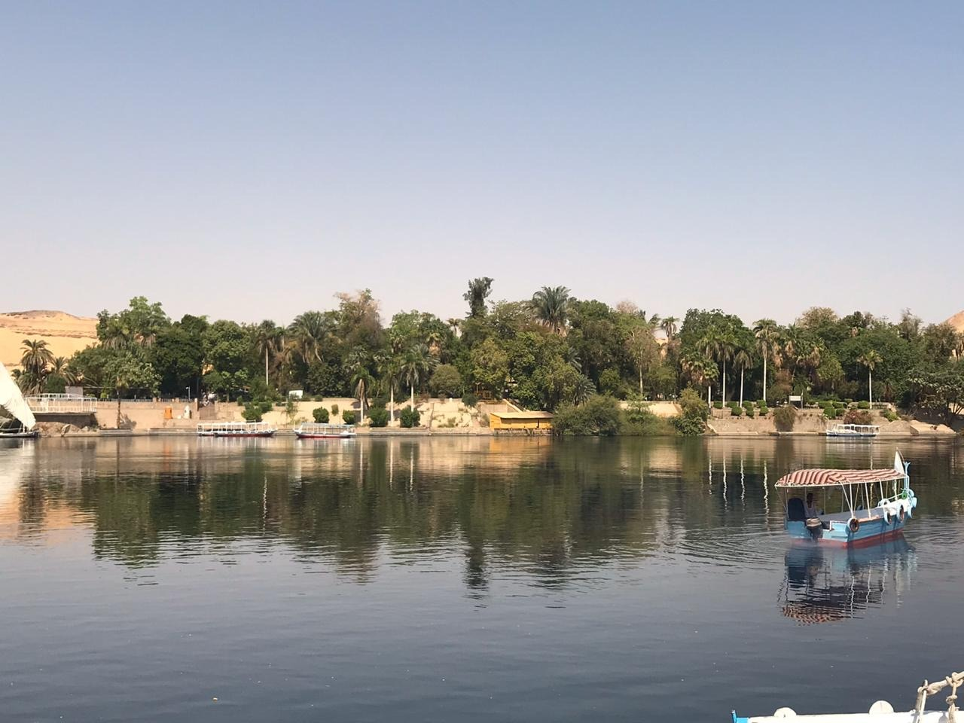
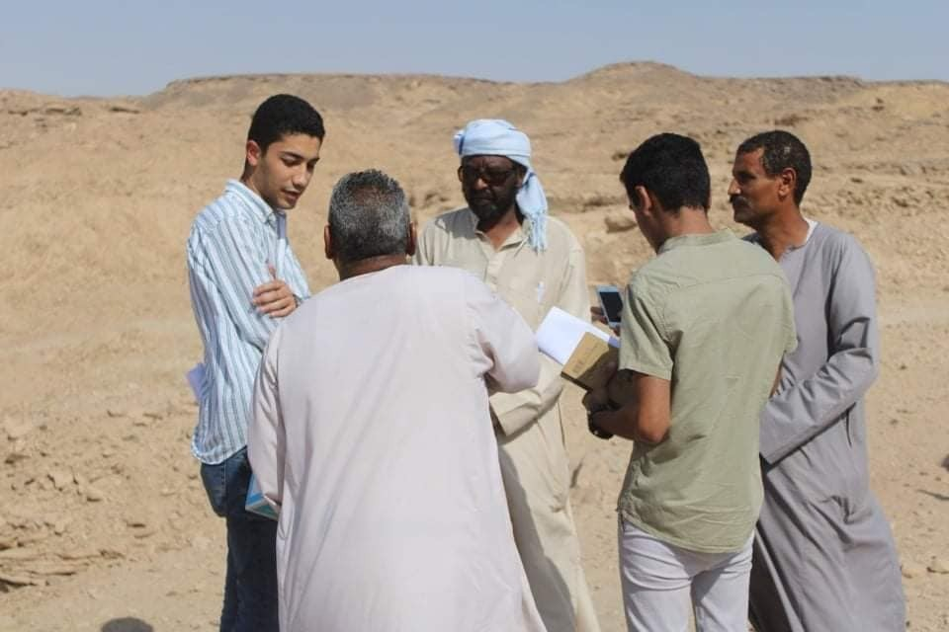
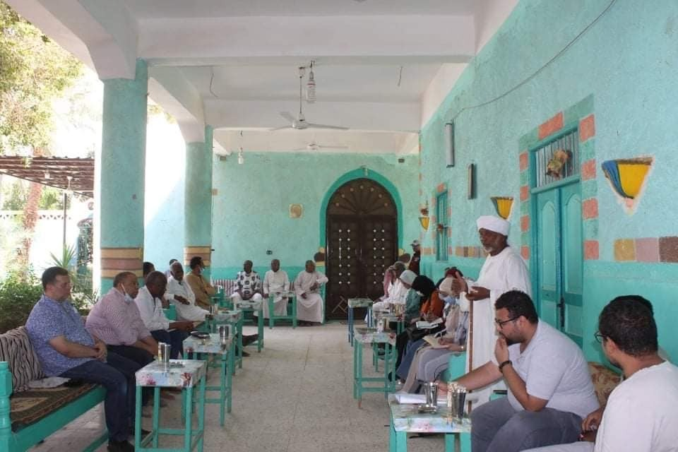
The contribution of the Department of Architecture to the development of the South Valley region through development projects
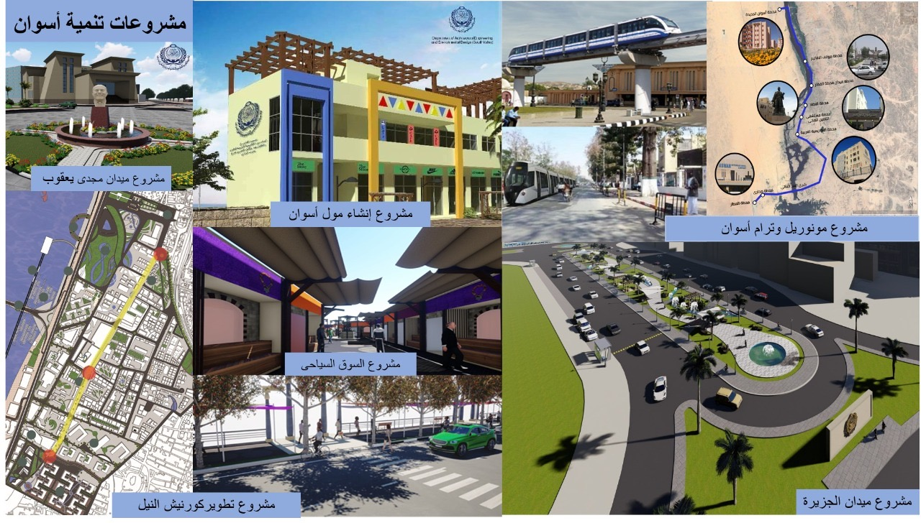

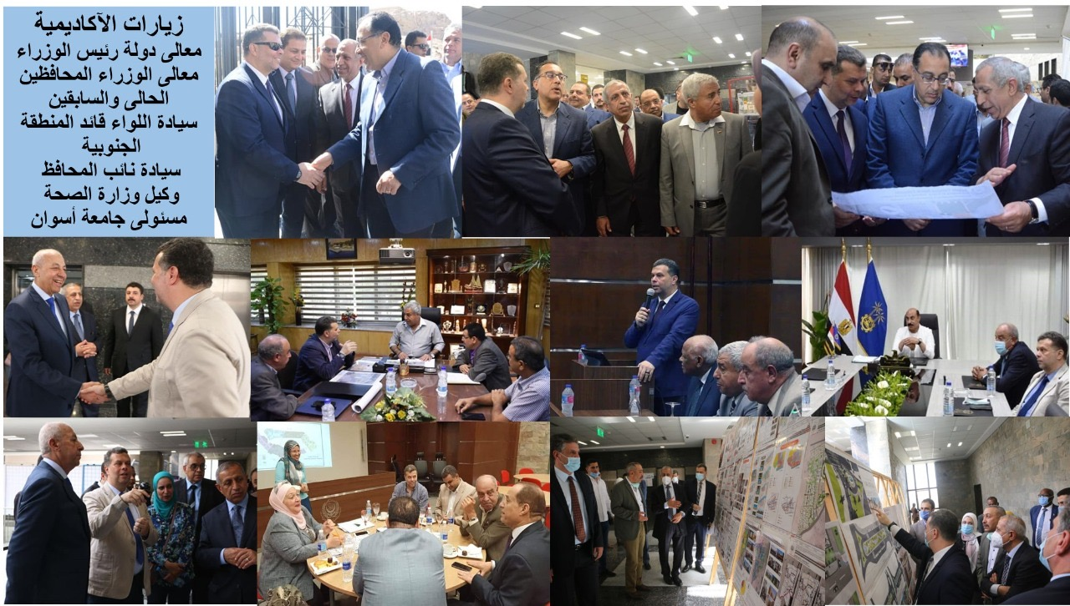
The contribution of the Department of Architecture to the preservation of the distinguished Nubian heritage architecturally and the sustainable development of the Nasr Nuba Center, north of Aswan
