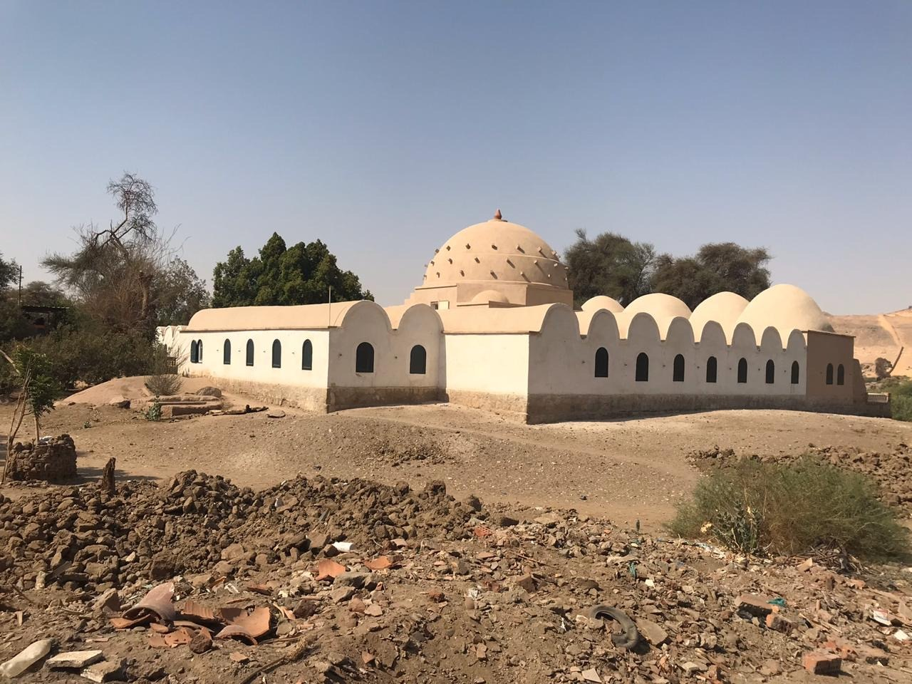
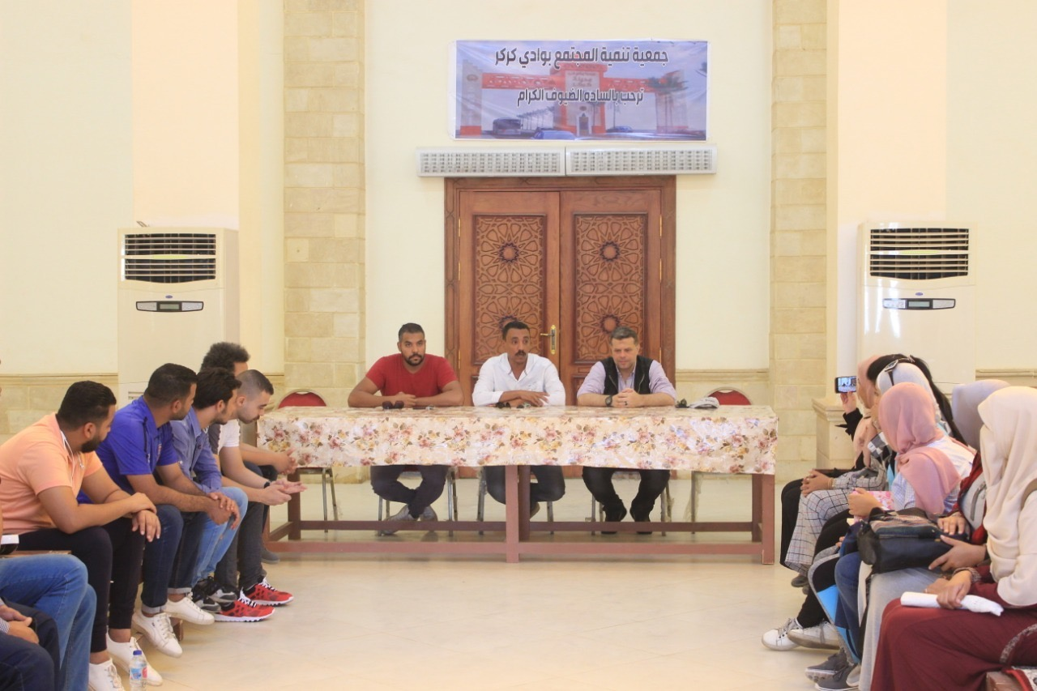
A field visit to explore the Nubian village of Karkar for students of the Department of Architecture to learn about the components of the urban village and how to develop it to attract the Nuba people to live in it and rebuild it completely

